** East West University**

**Lab Report**

**Semester:** Fall-2024

**Course Title:** Electronic Circuits **Course Code:** CSE251

**Sec:** 03

**Expt No: 01**

**Expt Name: I-V Characteristics and Modeling of Forward Conduction of a Diode**

**Group No: 07**

**Submitted by-**

**Name: Sheikh Sarafat Hossain**

**Id: 2022-3-60-109**

**Submitted to-**

**Dr. Sarwar Jahan**

**Associate Professor**

Department of Computer Science & Engineering

East West University

**Date of Performance: 31-10-2024**

**Date of Submission: 04-11-2024**

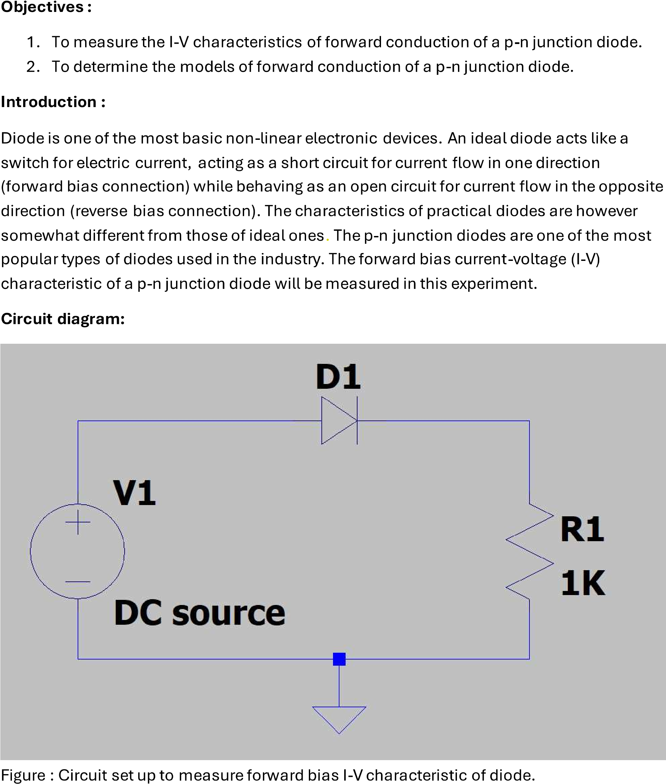

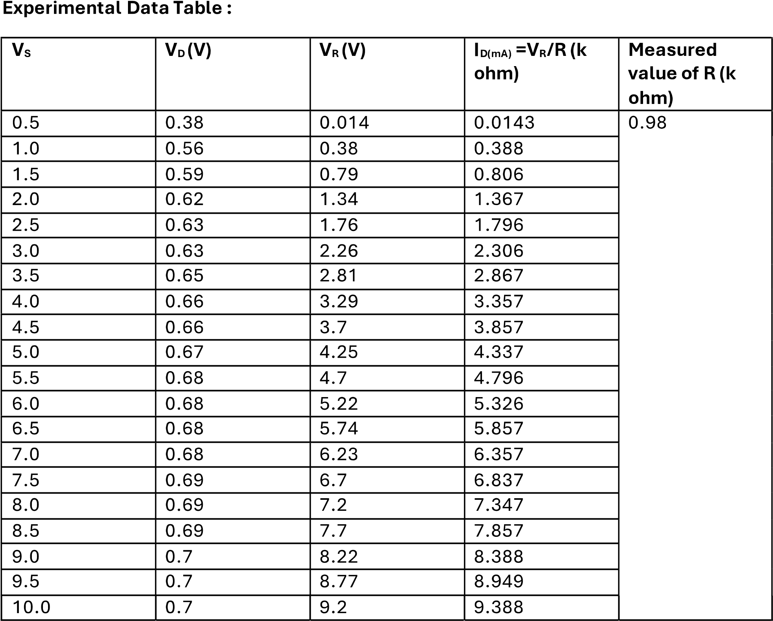

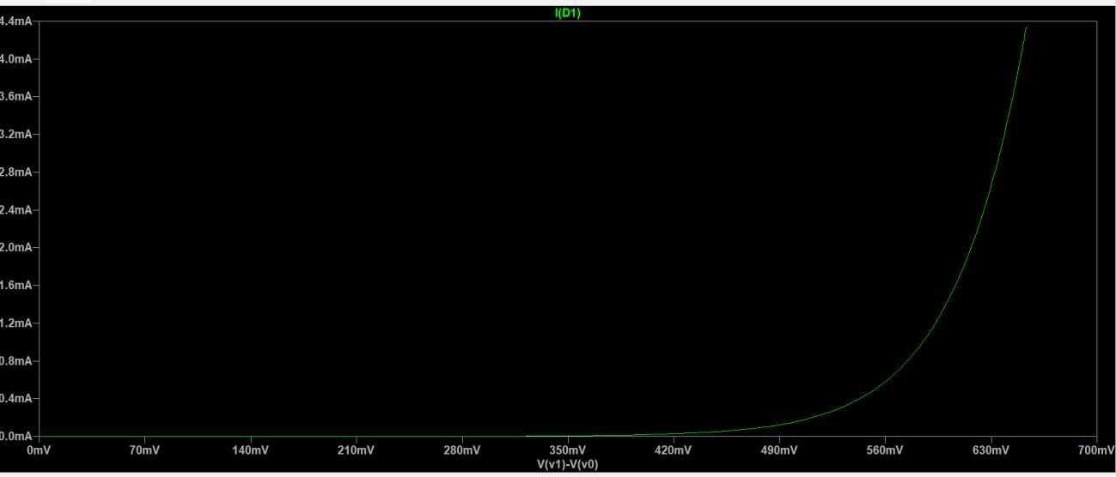

**Discussion:**

